|  |  |
| --- | --- |
| Document type: | **Case study narrative** |
| Author(s): | Anna Deluca, Joan Ballester, Rachel Lowe, Xavier Rodó |
| Sector(s): | Health |
| Case study name: | **Heat wave health impacts – weather, seasonal and climate change scales** |

**Background and scope of the problem**

*Heat waves cause thousands of preventable deaths world-wide every year. Currently in Europe, heat waves are the extreme weather event with highest impact in terms of number of fatalities [1]. A prime example is the anomalous and long duration heatwave during the summer of 2003 that caused over 70,000 excess deaths across twelve countries in Western Europe [2]. Extreme ambient heat induces health consequences such as heat stroke, cardiovascular and respiratory disease, metabolic imbalances, dehydration, and enhances negative side-effects of several classes of common pharmaceuticals. The Intergovernmental Panel on Climate Change (IPCC) projects with high confidence that the duration, frequency and temperatures during these events will continue to rise due to climate change in most parts of the world, including Europe [3]. Exposure to rising temperatures is a global phenomenon, but its impact is extremely local and highly related to socio-economic, political and individual physiological vulnerabilities [2].*

*In response to rising risks, preventive actions targeted to reduce the highly-avoidable temperature-related illnesses and deaths has become a high priority in recent decades in the European Region. Heat health early warnings systems (HHWS) are short term alert systems before and during heat-wave events that allow for timely public health responses. Until 2001, only one HHWS was operational in Europe (Lisbon), but after the 2003 heat wave many European countries have implemented operational HHWS. HHWS are often a key component of broader public health response plan to health risks of extreme warm temperatures, which are often referred to as “heat-health action plans” (HHAP) as per WHO guidance on the subject issued in 2008 [12]. HHWS serve the functions to forecast exposure risks and provide timely alerts, WMO and WHO have also issued guidance describing common approaches [13]. Depending on national and regional circumstances, different threshold levels of warning and action informed by HHWS, which link up with and inform the lead body of the heat health action plan to trigger public health responses [4].*

**Methods**

*This case study of the use of climate information for assessing heat wave health impacts on weather, seasonal and climate change scales. It was developed by conducting seven interviews.*

*Tables describing the use of climate information in full detail were filled. The tables are labelled following the agreed standardised nomenclature as SEC-HEA-UCT-003, SEC-HEA-UCT-004, SEC-HEA-UCT-005, and SEC-HEA-UCT-006. In the current document they are shortened to HEA3, HEA4, HEA5 and HEA6 (see table 1 in this document for a summary). Tables HEA3 and HEA4 correspond to two interviews with key stakeholders in charge of the HHWS and HHAP in the UK and Germany. Table HEA4 focusses on how an assessment of sub-seasonal-to-seasonal (S2S) climate forecasts of extreme temperatures could be incorporated in heat-health plans. Table HEA5 gives the perspective of a researcher who uses climate projections to assess the increased impact of future heat-waves on health due climate change.*

*Table 1. List of interviews, topics and correspondent SECTEUR tables.*

|  |  |  |
| --- | --- | --- |
|  | ***Interviewees*** | ***Application*** |
| SEC-HEA-UCT-003 (HEA3) | *Health and Meteorological Authorities of the UK* | Implementation of National Operational Heatwave Plan |
| SEC-HEA-UCT-004 (HEA4) | *Meteorological Authorities of Germany* | Implementation of National Operational Heatwave Plan |
| SEC-HEA-UCT-005 (HEA5) | *London School of Hygiene & Tropical Medicine, ISGlobal and WHO (Europe)* | Research |
| SEC-HEA-UCT-006 (HEA6) | *Public Health England* | Research |
| Contextual Interview 1- Global | *WHO/WMO* | International needs for extreme heat related climate services |
| Contextual Interview 2- North America | *National Oceanic and Atmospheric Administration NOAA* | US and North America experience |
| Contextual Interview 3 – Developing countries | *International Research Institute for Climate and Society, Columbia University* | Developing country needs for extreme heat related climate services |

**Findings – current and potential uses of climate information**

***Findings -* Implementation of National Operational Heatwave Plan**

*The case study considered in depth the experience of the UK and Germany to develop and operationalize HHWS. Table HEA3 describes the HHAP and HHWS of England [5]. We interviewed simultaneously the Met Office health impacts authorities and extreme events and health authority of Public Health England (PHE). Full details can be found in the corresponding table. The HHWS for England is based on the HHWS developed in France shortly after the 2003 heat-wave [5]. The climate information used is temperature, which is threshold-based using regionally-dependent temperature thresholds. Most European countries have very similar HHWS. Provincial level alarm are raised when these thresholds are surpasses. Finer-scale alerts (e.g. at the city level) are not issued. Population vulnerability or local effects, such as the Urban Heat Island effect, are not considered. The England HHAP plan is currently under external evaluation and it is expected to change in the forthcoming years. PHE aim for having a more impact based alert system.*

*Germany has a more sophisticated HHWS based on a human energy balance model of a human body used to compute the perceived temperature [6]. Table HEA4 is based on an interview with the head of the Research Centre Human for Biometeorology of the German Meteorological Service (DWD), who is responsible for issuing heat-wave warnings. In this case, several meteorological variables are taken into account. For computing the perceived temperature, thermo-physiological factors, such as the metabolic rate and clothing are taken into account, together with air temperature, mean radiant temperature (which considers short- and long wave radiation fluxes), air humidity and wind speed velocity at 1.1 metres. In addition, perceived temperature during the last 30 days as well as night temperature indoors are used to take the final decision of rising an alert or not. DWD also alerts mostly at regional level (specifically county level) and different elevation levels, but also has specific alerts for large cities considering the Urban Heat Island Effect, as well as specific early alerts for vulnerable population groups, such as the elderly.*

*Most European HHWS operate only at regional scale and do not use climate information with lead times beyond 1-2 days. This is due to limitations in the health systems to convert early information into relevant actions, that they many decision needs are short term, but also due to the limited skill of weather models at longer lead times (beyond one week) in Europe [7]. PHE indicated that a cost-benefit detailed analysis would be needed to assess the impact of issuing false alerts on system performance and public perception. The DWD representative, had a very authoritative opinion: 'the cost of a wrong prediction is huge in term of losing the trust of the users and authorities'. Then, they are not intending to go beyond two days in advance for a final warning or alert. In table HEA5 we describe how climate information is used to perform an assessment of the extent to which sub-seasonal-to-seasonal climate forecasts could be incorporated into heat-health action plans. For this, apparent temperatures (which combine air temperature and dew point temperatures at 2 metres) were calculated for data from reanalysis and seasonal forecast hindcasts of the European Center of Medium Weather Forecast (ECMWF). Results showed a decreasing transition in skill between excellent predictions when using observed temperature, to predictions with no skill when using forecast temperature with lead times greater than one week. The performance of this climate service framework was found not to be limited by the mortality model itself, but rather by the limited predictability of the climate variables, at S2S time scales, over Europe.*

***Findings –* climate change assessment on heat risks on health**

*To cope with the increasing heat risks on health, improved products that describe future trends of heat waves farther into the future are needed to inform the planning process. In table HEA6 we interviewed the Principal Climate Change Scientist of Public Health England and co-editor of the Health Effects of Climate Change in the UK 2012 [8]. They conduct research assessments and quantifies the effects of climate change on health, with a focus on temperatures, air pollution and urban climate. The representative pointed out that they mostly used atmospheric temperature at 2m (maximum and minimum daily temperature, temperature anomalies, temperatures above a threshold depending on climatology) and dew point temperature at 2m in observations, reanalysis and climate projections datasets. Full details can be found in table HEA6.*

*Finally, we also conducted three additional interviews which provided a global contextual perspective, to the ongoing work and issues in Europe. In them, we discussed the need for greater awareness and sharing of national and local-scale initiatives to harmonize approaches and learning for heat risk management worldwide. Challenges to raise awareness and to develop HHWS in developing countries were also cited. No tables were produced for these interviews, as the specific target of SECTEUR is Europe. Highlights of those conversations described below provided very relevant for recommendation on further end-user engagement and gaps, and how the European experiences and needs can contribute to and learn from global activities.*

***Findings –* broader context (North America, Global and developing countries perspective)**

*We had a virtual meeting together with the* National Oceanic and Atmospheric Administration (*NOAA) Health and Integrated Climate Research Lead and the WHO/WMO joint office for Climate and Health. The WMO/WHO joint office for Climate and Health (SECTEUR health sector champion) and the NOAA Climate Program Office are together developing the Global Heat Health Information Network (GHHIN). The GHHIN aims to be a network of scientists, professionals and policy-makers focused on enhancing and multiplying the global and local learning and resilience-building for heat health that is already occurring.*

*NOAA is developing in the United States, but also working across Canadian and Mexican borders, the US-NOAA national Integrated heat health information system and undergoing an extensive engagement plan. Many things can be learnt from this experience about how to engage with health community users. The key message from them is 'long term engagement is a must'. They are currently working towards identifying decision makers, mapping their specific needs/questions to be answered, and identifying high risk population within pilot regions. They are also creating national scale excessive heat warning maps that can be tailored by the user. In this process, they find, as it has been also already observed in the CDS development by several contractors, that there is demand of a very high number of very specific indices. Then it is important to give the tools to users to create their own climate impact indicators. NOAA representatives also indicated that the skill of forecasting products going beyond a week are currently not sufficient to inform intervention measures.*

*An expert in climate change risk from the International Research Institute for Climate and Society of Columbia University was also interviewed about the incorporation of long-term climate information into decision-making and her experience in Bangladesh. Their are working on determining the characteristics and changing risks of heat waves in Bangladesh and their health impacts. They noted that in countries without yet a coordinated response plans much work remains to be done around the identification of end users for heat information in developing countries. The first heatwave of 2017 have already taken place in Bangladesh, with temperatures higher than 38°C, leading to panic in factories as hundreds of workers collapsed due to heath related illnesses, with many of them having to be taken to the hospital [9]. For those countries, there is a general previous need to build such demand for such information within the government and the public health sector, as well as building capacity both to deliver reliable and understandable forecast information and to respond to a warning when it is issued. There are very few examples of HHWS in the developing world. This is partially due to the concentration of developing countries being located in tropical regions where populations are acclimatized to warm conditions, but are now being confronted with extreme heat which exceeds previously experiences and conditions. Lack of research and epidemiological surveillance often limits scientific evidence and recognition of heat wave mortality impacts.*

***Barriers - building on past projects***

*This case study is informed by lessons from previous multi-country European projects. The main barriers for the uptake of climate information were clearly identified by the project “Improving public health responses to extreme events” (EuroHEAT) co-funded by the WHO and the European Commission [10]. Around 100 scientists, scientific advisors, meteorologists, environmental scientists and policy advisors from 20 countries contributed to the project from 2004 to 2007. Barriers are institutional - in the form of low level of exchange and hierarchies of different institutions; technical – due to the different languages of different disciplines (scientists and medical doctors); the difficulty communicating uncertainty; and more importantly the difficulty of taking decisions for action on the basis of various levels of probability. Moreover, most health systems are already working at full capacity without having the possibility to have an impact beyond behavioural changes. For example, there is not the option of having more doctors or nurses on shift due to a heatwave alert. But medium/short term measures can still be very effective if vulnerable population groups are properly targeted and exposure is reduced. Long term measures can be more effective when linked to urban planning, energy consumption, transport policies or building constructions regulations. We have also builded up on the “*European Provision Of Regional Impacts Assessments on Seasonal and Decadal Timescales” (*Euporias) project. The first contacts with some of the interviewed were done within this project which finalised last year. HEA5 builds up on research also developed during that project.*

**Summary and recommendations**

*Climate information and climate services must be integrated in the decision-making process to be effective. The complexity in using climate information is far beyond issues related to data collection and modelling. The first step is the identification of decision-makers, and understanding the temporal and spatial scales of the decisions they need to make. Guidance on the use and interpretation of data is also key. We also strongly recommend the CDS to provide more tools to assess the skill of climate information as it is not worth developing products if the skill is inadequate. For this reason, as the skill beyond 7-days in Europe is low but this is not the case for other regions in the world, most of them located in the tropical and subtropical belts, we would advocate for developing global products able to adapt to different levels of predictability in different regions.*

*However, many developing countries are not yet ready for such products and PHE and the WHO/WMO joint officer think that it is much more valuable to give local support and to help each country to build up their own system. Continuous engagement, coordination and collaboration must be prioritised. It is also important to build on past efforts and make efforts to ensure sustainability and main-streaming after a project-life span reach their end. We encourage the CDS and ECMWF to review opportunities to support previous and current projects and strongly coordinate with weather data national providers to continue valued climate services such us the created by DWD in the context of the EuroHEAT project. They created a Climate Information Decision Support Tool for Heat in Europe providing medium term 3 and 10 days ahead heat warnings [10]. We consider this kind of initiatives crucial for the creation of demand for the use of climate information beyond weather scales.*

*Final summaries can be find next in table form. Next table 2 and 3 summarize use-driven barriers, gaps and recommendations for the future uptake and provision of climate information in the health sector according to the study findings. In table 4 a summary of the climate information used in the analysed cases is displayed.*

*Table 2. Summary of barriers and gaps.*

|  |
| --- |
| **Barriers & Gaps for the uptake of climate information - Summary** |
| * Institutional - in the form of low level of exchange and hierarchies of different institutions. Some consequences are the artificial distinction between weather and climate scales or difficulties in identifying decision-makers |
| * Communication - due to the different languages of different disciplines (scientists and medical doctors); the difficulty communicating uncertainty |
| * Capacity of health systems - most health systems are already working at full capacity without having the possibility to have an impact beyond behavioural changes |
| * Dealing with uncertainty - and more importantly the difficulty of taking decisions for action on the basis of various levels of probability. How to communicate for reducing risk of possible loss of credibility in case of false alarms |
| * Complexity of heat impacts – difficulties in quantifying and modelling climate impacts on health. Relationship are generally non-lineal, multi-factorial and highly complex to model |
| * Business models and market development approaches poorly adapted for the health sector specificities |
| * Lack of standards – for example in the definition of heat wave, risk quantification, etc. Need of local development due to very strong local differences on needs and characteristics, but need to harmonize and improve information and opportunity sharing across the different communities |

*Table 3. Recommendations for future provision.*

|  |
| --- |
| **Recommendations for future provision - Summary** |
| * Facilitate compatibility with surveillance data by providing tools able to aggregate information spatially using standarised NUTS classification of the Eurostat <http://ec.europa.eu/eurostat/web/nuts/overview> |
| * Increase skill of seasonal to annual temperature projections for most of Europe by funding research on new possible sources of predictability |
| * Remove distinction between weather and climate scales (beyond 1 month lead time). Facilitate access to forecast data under one month at European level. |
| * Provide higher spatial resolution (ideally 1 km or less) but not at the expense of reducing skill, in order to assess demands of city-level assessments |
| * Provide tools for assessing skill for different lead times, regions and times of the year. |
| * Facilitate building on past efforts by giving accessibility to users results. Make efforts to ensure sustainability and mainstreaming after a project-life span reach their end |
| * Facilitate projects where climate information and climate services are integrated in the decision-making |
| * Facilitate research and epidemiological surveillance often limits scientific evidence and recognition of heat wave mortality impacts in developing countries |
| * Provide R programming language interfaces, as this software is widely use by technicians dealing with health data to facilitate integration |
| * Facilitate permanent dialogue with end-users, facilitate the creation of networks of users and purveyors. Many times stake-holders play both roles: they are users and purveyors. |
| * Follow the European mandate regarding metadata INSPIRE Directive <http://inspire.ec.europa.eu/metadata/6541> |

*Table 4. Climate information used at each case table. Most users only used temperature and dew point temperature. Only in HEA4 uses further information such as mean radiant temperature, air humidity and wind speed velocity. We could only find interested for seasonal forecast from the research perspective. Note that all interview correspond to the public sector (research institutes and governmental agencies). High interest in developing products at city level.*

|  |  |
| --- | --- |
| **Climate Information Products** | **Use Case Table** |
| Observations | HEA3, HEA4, HEA5, HEA6 |
| Weather forecast | HEA3, HEA4, HEA5 |
| Climate Projections | HEA6 |
| Reanalysis | HEA3, HEA4, HEA5, HEA6 |
| Climate Impact Indicators (computed) | HEA4, HEA5, HEA6 |
| Information used as input data for complex models | HEA4, HEA5, HEA6 |

***References***

*[1] European Environment Agency (EEA). Climate Change, Impacts and Vulnerability in Europe 2012; European Environment Agency: Copenhagen, Denmark, 2012.*

*[2]* *Robine, J.-M.; Cheung, S.L.K.; Roy, S.L.; Oyen, H.V.; Griffiths, C.; Michel, J.-P.; Herrmann, F.R. Death toll exceeded 70,000 in Europe during the summer of 2003. C. R. Biol. 2008, 331, 171–178.*

*[3] IPCC, 2014: Climate Change 2014: Synthesis Report. Contribution of Working Groups I, II and III to the Fifth Assessment Report of the Intergovernmental Panel on Climate Change [Core Writing Team, R.K. Pachauri and L.A. Meyer (eds.)]. IPCC, Geneva, Switzerland, 151 pp.*

*[4] D'Ippoliti, D., Michelozzi, P., Marino, C., De'Donato, F., Menne, B., Katsouyanni, K., ... & Atkinson, R. (2010). The impact of heat waves on mortality in 9 European cities: results from the EuroHEAT project. Environmental Health, 9(1), 37.*

*[5] EuroHEAT. Improving public health responses to extreme weather/heat-waves – Meeting Report 22-23 March 2007. Downloaded from* [*http://www.euro.who.int/__data/assets/pdf_file/0018/112473/E91350.pdf*](http://www.euro.who.int/__data/assets/pdf_file/0018/112473/E91350.pdf)

*[6] Matzarakis A. (2017) The Heat Health Warning System of DWD—Concept and Lessons Learned. In: Karacostas T., Bais A., Nastos P. (eds) Perspectives on Atmospheric Sciences. Springer Atmospheric Sciences. Springer, Cham*

*[7] Lowe, R., García-Díez, M., Ballester, J., Creswick, J., Robine, J. M., Herrmann, F. R., & Rodó, X. (2016). Evaluation of an early-warning system for heat wave-related mortality in Europe: implications for sub-seasonal to seasonal forecasting and climate services. International journal of environmental research and public health, 13(2), 206.*

*[8] Vardoulakis, S. and Heaviside, C. [eds.] (2012) Health Effects of Climate Change in the UK 2012 – Current evidence, public health recommendations and research gaps. Health Protection Agency. Centre for Radiation, Chemical and Environmental Hazards, UK. ISBN: 978-0-85951-723-2.* [*Link to PDF*](http://www.hpa.org.uk/hecc2012)*]*

*[9]* [*http://www.thestar.com.my/news/regional/2017/05/26/panic-in-bangladesh-factories-as-workers-collapse-in-heatwave/*](http://www.thestar.com.my/news/regional/2017/05/26/panic-in-bangladesh-factories-as-workers-collapse-in-heatwave/)

*[10] Website of the EuroHEAT tool, discontinued at the moment (status on May 2017).* [*http://www.euroheat-project.org/dwd*](http://www.euroheat-project.org/dwd)

*[11]* [*https://www.gov.uk/government/publications/heatwave-plan-for-england*](https://www.gov.uk/government/publications/heatwave-plan-for-england)

*[12] http://www.euro.who.int/en/publications/abstracts/heathealth-action-plans*

*[13]a*[*http//www.who.int/globalchange/publications/WMO_WHO_Heat_Health_Guidance_2015.pdf*](http://www.who.int/globalchange/publications/WMO_WHO_Heat_Health_Guidance_2015.pdf)

***Graphical descriptions***

Next graphical descriptions can be found of the flow of climate information used to inform heat-health action plans or perform climate change assessments.

Figure 1. Figure reproduced from Ref [6] with permission of the authors. It a visual description of how the German HHWS works.

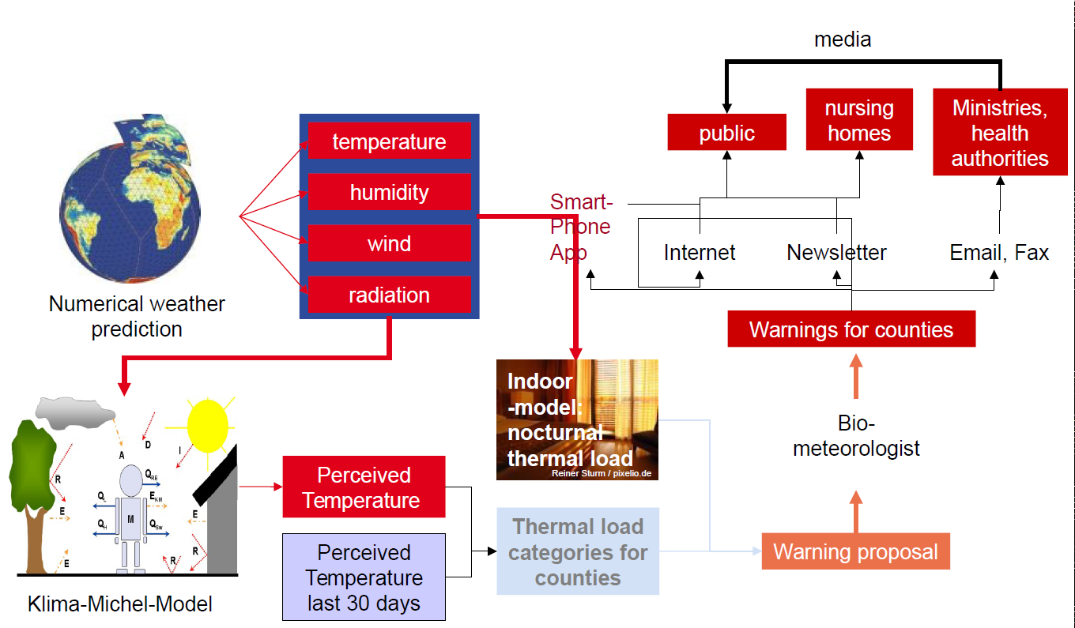

Figure 2. Heatwave Alert level of the Heatwave plan for England. Most countries in Europe have a similar alert system. Reproduced from the Heatwave plan for England – protecting health and reducing harm from severe heat and heatwaves document that can be found in [11].

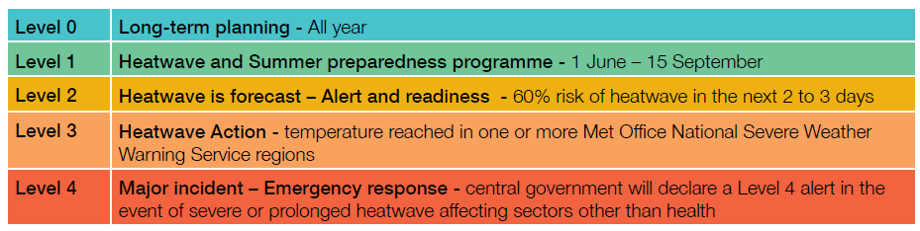

Figure 3. This figure describes a typical flow of climate information and actors involved in a climate change assessment of heat stress risk